**Smartcookie Details**

**-Komal Survase (Software Tester)**

* **Smartcookie Flow Chart**

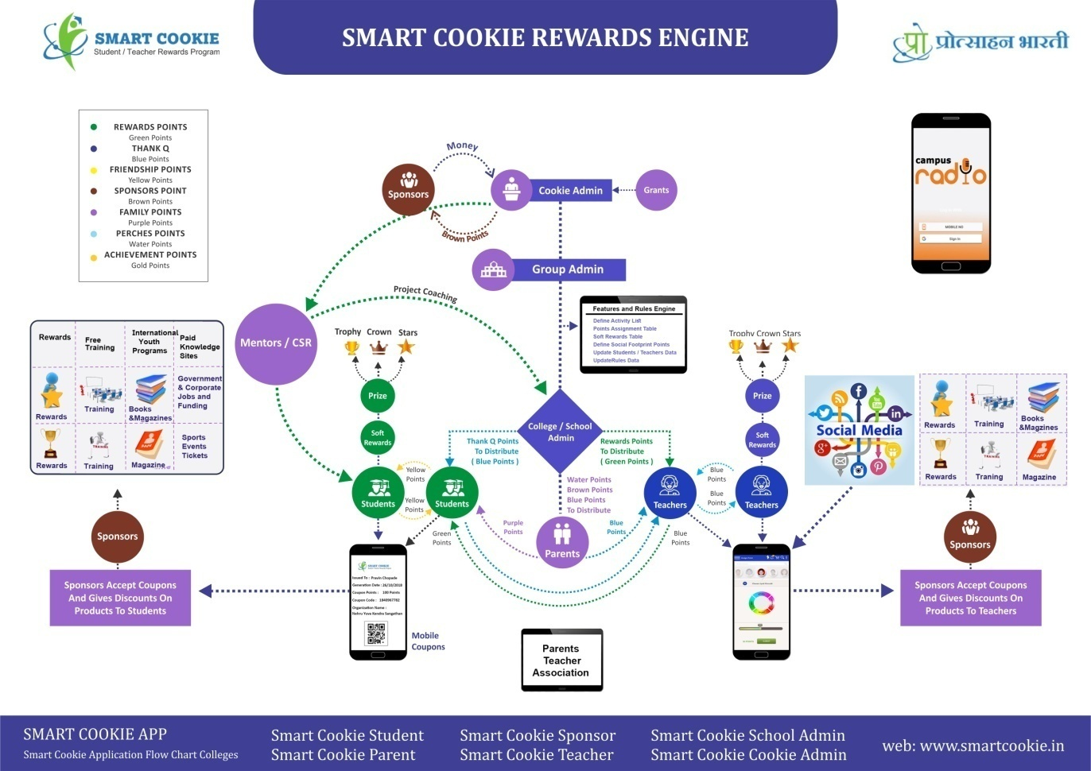

* **Points**
* Points From Cookie Admin

Can distribute blue or green points to Group or Schools

* Points From Group Admin

Can distribute blue or green points to Schools

* Points for distribution

School Admin to teacher / HR Admin to manager = Green Points

School Admin to student /HR Admin to employee=Blue Points

* Reward Points

Student to teacher / Employee to manager = Blue Points

(Thank you points)

Teacher to student /Manager to employee=Green Points

(Rewards Points)

* Yellow Points (Friendship Points)

Student to Student

Employee to Employee

* Brown points (Sponsor Points )

Table -referral_activity_reasons

(Contains all the reasons for getting brown point)

-360 feed back 1st time for each subject

-Self Registration

-Register to Campus TV ,Campus Radio

-Play Track on tv/Radio

-Like channel of TV/Radio

* Purple (Family Point )

Parent gives to points to their child (Student)

* Water point

-Can get from gift card given by Cookie Admin

-School Admin can give water points to Student/Teacher or Employee /Manager for distribution.

-Cookie Admin to school Admin

Teacher to Teacher water to blue

Student to student – yellow to yellow

If yellow not available - Green to yellow

* Soft reward

Student/Employee can buy soft rewards using their green points.

* **Naming conventions in School Admin / HR Admin**

Teacher  -🡪 Manager

Department --> Department

Course Level --> Employee Level

Degree --> Corporate

Branch --> Section

Class --> Team

Division --> Location

Semester --> Default Duration

Academic Year --> Financial Year

Student --> Employee

Teacher --> Manager

Subject --> Project

School-🡪Organization

* **Teacher/Manager Enitity type details**

**Table Name : tbl_teacher**

* **entity_type_id**

Teacher =103

Manager = 203

* **t_emp_type_pid**
* **For School**

Teacher = 133,134

HOD= 135

Principal = 137

Non Teaching Staff=140

* **For Corporate /HR/Organization**

Manager=133,134

Reviewing Officer=135

Appointing Authority=137

Member Secretary=139

Vice Chairman=141

Chairman=143

* **Student/Employee entity type details**
* **entity_type_id**

**Table Name : tbl_student**

Student =105

Employee = 205

* Tables for store reward points

Table name = tbl_student_reward

(Store the reward points got by the particular student/employee)

Table name =Teacher

(Store the reward points got by the particular teacher/manager)

* Logs

Student/Employee- tbl_studentpointslist

Teacher/Manager -tbl_teacher_point

* Related to code
* Security function file

Smartcookie->Core->securityfunctions.php

Common global variables

All core/.... and core/Version2/.... files are used this common code

(Included in conn.php)

* Frond 1st loading page

Application->View ->index.php

* Tables for reference

1. Cookie Admin /Cookie Admin Staff– Core (tbl_cookieadmin)
2. School Admin/School Admin Staff / HR Admin/HR Admin Staff – Core (tbl_schooladmin/ tbl_school_adminstaff)
3. Group Admin /Group Admin Staff - Core->Group Admin

(tbl_cookieadmin/ tbl_cookie_adminstaff)

1. Teacher/Manager-CI (Default controller - Teacher)

(tbl_teacher)

1. Student/Employee- CI (Default Controller- main )

(tbl_student)

1. Sponsor/Salesperson/Parent – CI

(tbl_sponsor/tbl_salesperson/tbl_parent)

* 360 Feedback-

Student gives feedback to teacher for particular subject.

From entity to to entity is stored in the table

rule_engine_for_referral_activity .

* Teacher (133/134)

-Contribution to society

-Teaching process

* Principal

-Contribution to society

-Teaching process

-Departmental Activities

-ACR (Annual Confidentiality Report)

* HOD

-Contribution to society

-Teaching process

-Departmental Activities

* Upload panel 1 to 8 fields uploading is mandatory to open other fields.
* Environments

Dev- Development

Test- testing

Master- Production (Live)